**Uniquemedia: A Project Collaboration Social Media Platform**

**Student Name: Md Imon Kabir**

**Course: Database Programming**

**Professor: Dr.Ratvinder Grewel**

**Date:28 Novemmber 2025**

1. **Introduction:**

Effective communication is essential when a group is working together on an academic or technical project. Members often need to share updates, exchange opinions, provide feedback, and coordinate tasks. To support these needs, this project introduces Uniquemedia, a lightweight, database-driven social media platform designed specifically for project collaboration.

The platform enables users to:

• Create posts containing text and images

• Share thoughts, project updates, and suggestions

• Interact through likes, dislikes, and comments

• View announcements posted by staff or project supervisors

• Log in and sign up as authenticated users

Although Uniquemedia includes a simple user interface, the primary focus is on database design, SQL functionality, and data integrity, which form the core requirements of this Database Programming course.

**2. Mini-World Scenario:**

The mini-world scenario represents a team communication system within a shared project environment.

In this world:

• Users may be team members or staff/supervisors.

• Users post updates, ask questions, and share opinions.

• Staff members post official instructions or guidance.

• Posts can include images, allowing sharing of screenshots, drafts, and project materials.

• Reactions (likes/dislikes) allow quick feedback.

• Users can comment on posts to create discussions.

Everything that happens in the website is stored and managed by the MySQL relational database, making the database the engine of the entire system

**3 Problem Scope**

The purpose of Uniquemedia is to support communication within a project team consisting of students and staff members. The system enables users to share project updates, post ideas, upload images, comment on posts, and react using likes or dislikes. Staff members post official announcements, creating a structured communication environment.

Functional Requirements

1. The system must allow users to sign up and log in securely.

2. Users must be able to create text-based posts.

3. Users must be able to upload optional images with their posts.

4. Users must be able to like or dislike a post.

5. Users must be able to comment on any post.

6. Staff users must have a dedicated announcement feed.

7. All posts, comments, reactions, and user activities must include timestamps.

8. The system must store all information persistently in a MySQL relational database.

Non-Functional Requirements

1. The database must maintain referential integrity through foreign keys.

2. The database design must be normalized to at least Third Normal Form.

3. The system must respond efficiently to feed queries.

4. Indexes must be used to speed up sorting and filtering.

5. The interface must be simple and easy for users to navigate.

**3.ER Diagram:**

The database consists of four major entities:

Users, Posts, Comments, and Post Reactions.

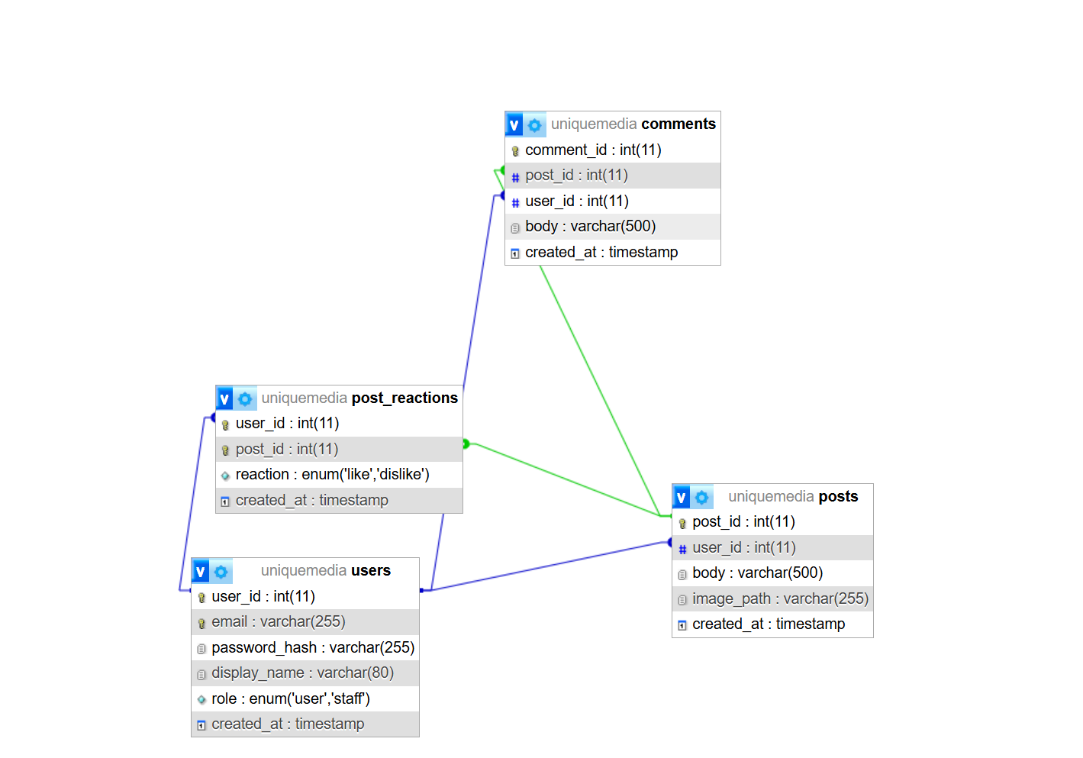

**4. Functional Dependencies**

users

• user_id → email, password_hash, display_name, role, created_at

• email → user_id

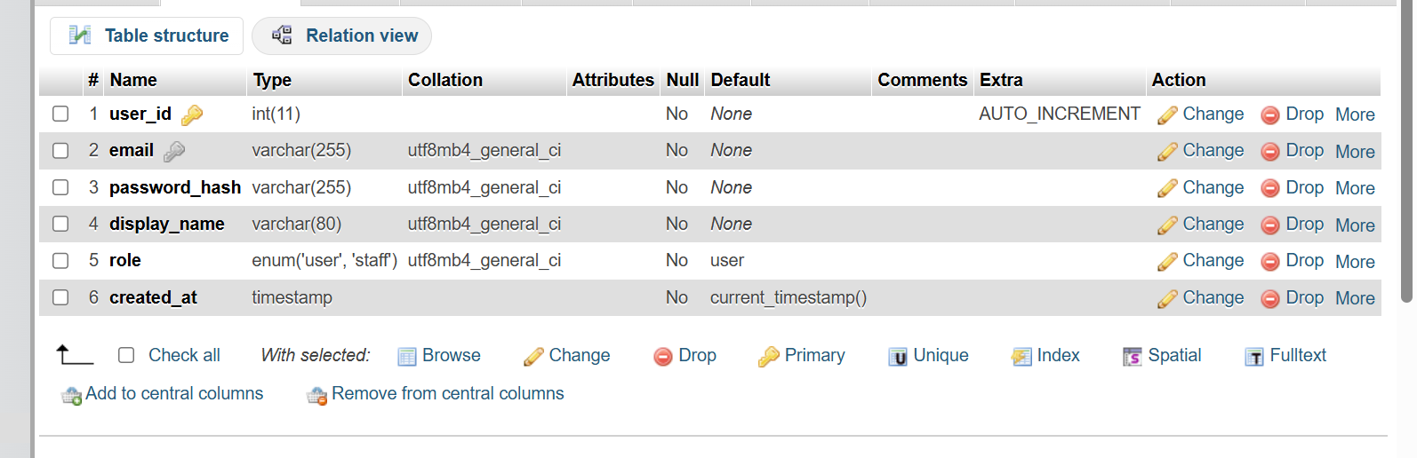

Posts

• post_id → user_id, body, image_path, created_at

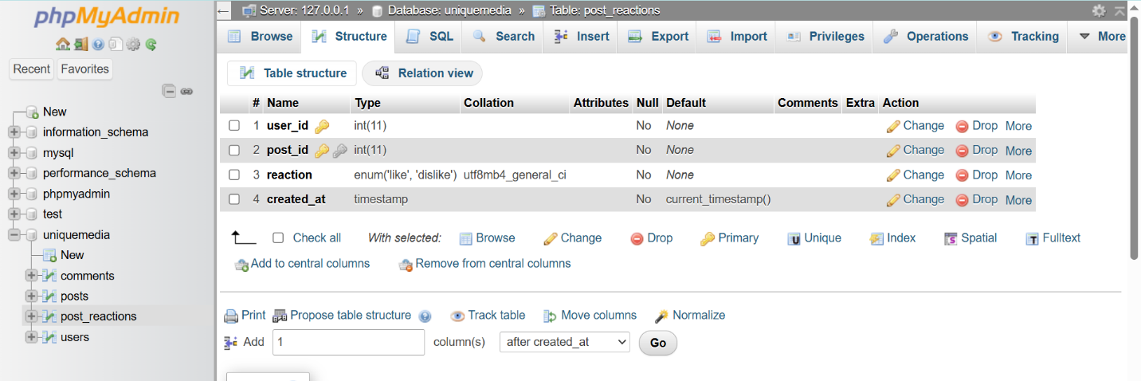

comments

• comment_id → post_id, user_id, body, created_at

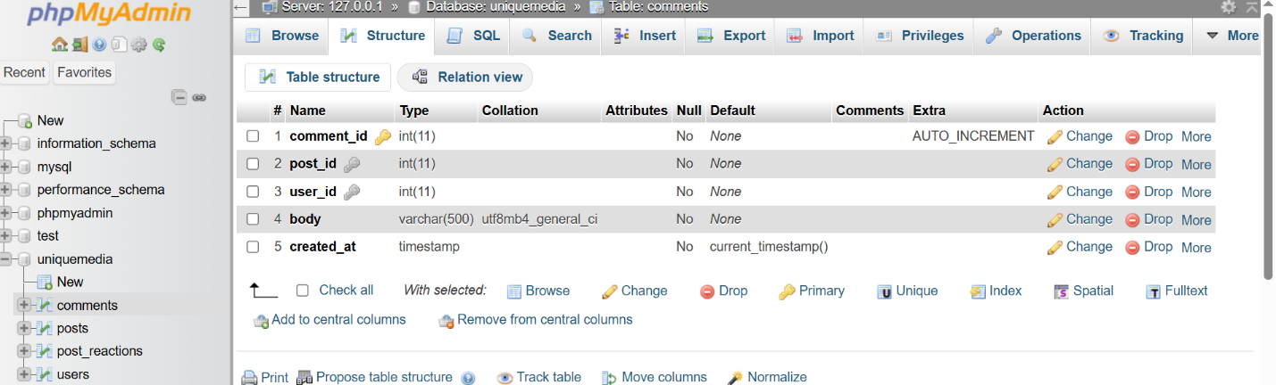

post_reactions

• (user_id, post_id) → reaction, created_at

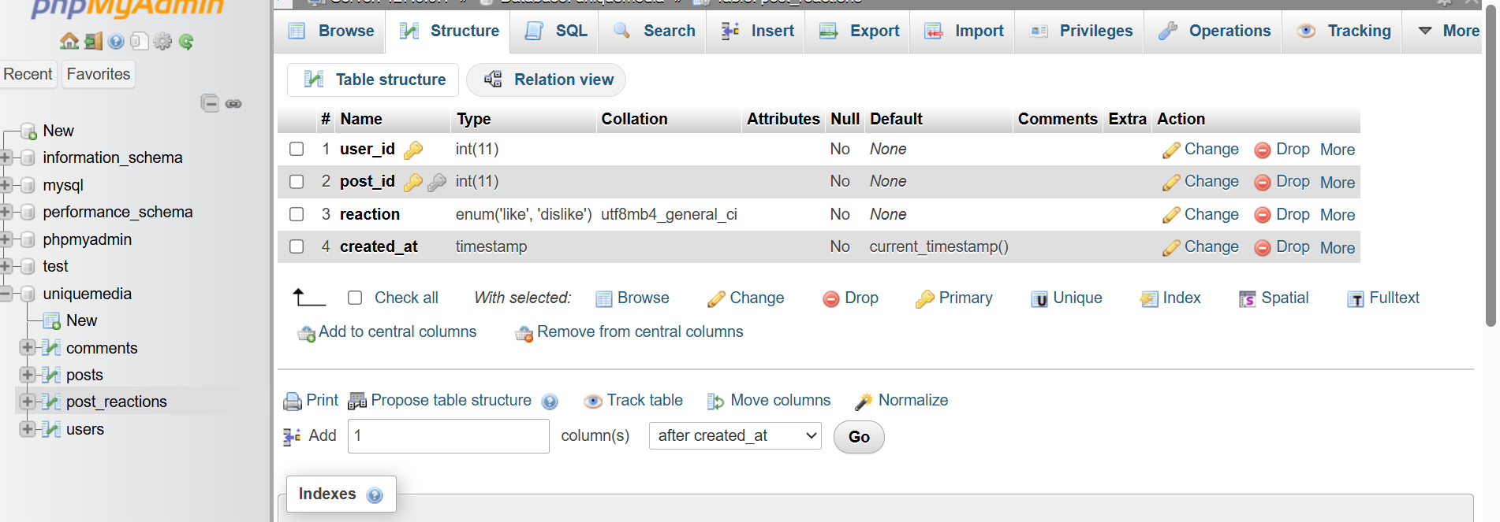

**5. Normalization**

The database follows Third Normal Form (3NF):

✔ 1NF

•All attributes are atomic.

•No repeating groups.

✔ 2NF

•Every non-key attribute is fully dependent on the primary key.

•Composite key in post_reactions correctly handled.

✔ 3NF

•No transitive dependencies.

•All attributes depend directly on the key.

This ensures minimal redundancy and reduces update anomalies.

**6.Relational Algebra**

RA1 – Posts with Author Names

π(post_id, body, display_name) (Posts ⨝ Users)

RA2 – Staff-Only Posts

σ(role = ‘staff’) (Users ⨝ Posts)

RA3 – Comments on a Specific Post

σ(post_id = X)(Comments)

RA4 – Posts with Reactions

Posts ⨝ Post_Reactions

RA5 – Total Posts Per User

γ user_id; COUNT(post_id) → total_posts (Posts)

**7. Database Schema (DDL)**

Below are core table creation statements:

**Users:**

CREATE TABLE users (

user_id INT AUTO_INCREMENT PRIMARY KEY,

email VARCHAR(255) UNIQUE NOT NULL,

password_hash VARCHAR(255) NOT NULL,

display_name VARCHAR(80) NOT NULL,

role ENUM('user','staff') NOT NULL DEFAULT 'user',

created_at TIMESTAMP DEFAULT CURRENT_TIMESTAMP

);

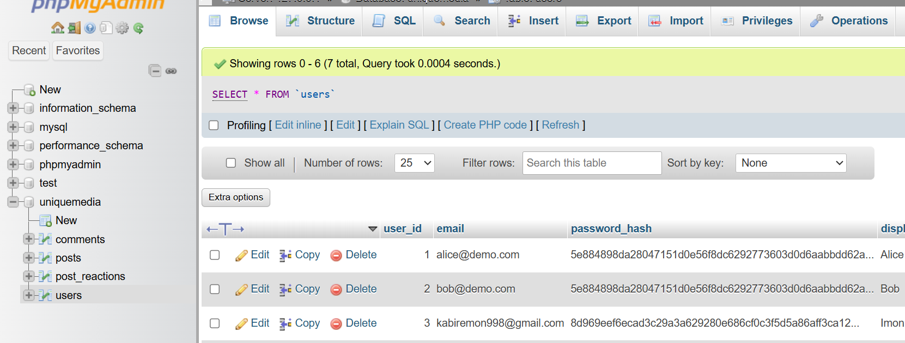

**Posts:**

CREATE TABLE posts (

post_id INT AUTO_INCREMENT PRIMARY KEY,

user_id INT NOT NULL,

body VARCHAR(500) NOT NULL,

image_path VARCHAR(255),

created_at TIMESTAMP DEFAULT CURRENT_TIMESTAMP,

FOREIGN KEY (user_id) REFERENCES users(user_id) ON DELETE CASCADE

);

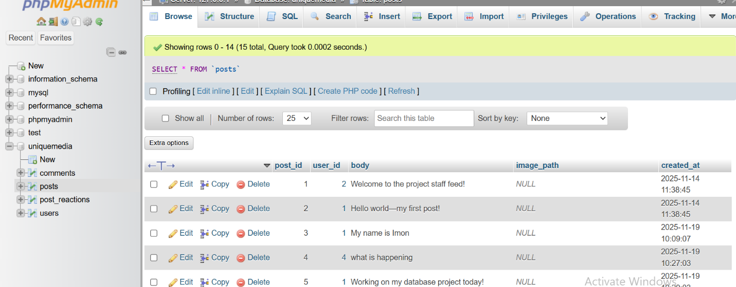

**Comments:**

CREATE TABLE comments (

comment_id INT AUTO_INCREMENT PRIMARY KEY,

post_id INT NOT NULL,

user_id INT NOT NULL,

body VARCHAR(500) NOT NULL,

created_at TIMESTAMP DEFAULT CURRENT_TIMESTAMP,

FOREIGN KEY (post_id) REFERENCES posts(post_id),

FOREIGN KEY (user_id) REFERENCES users(user_id)

);

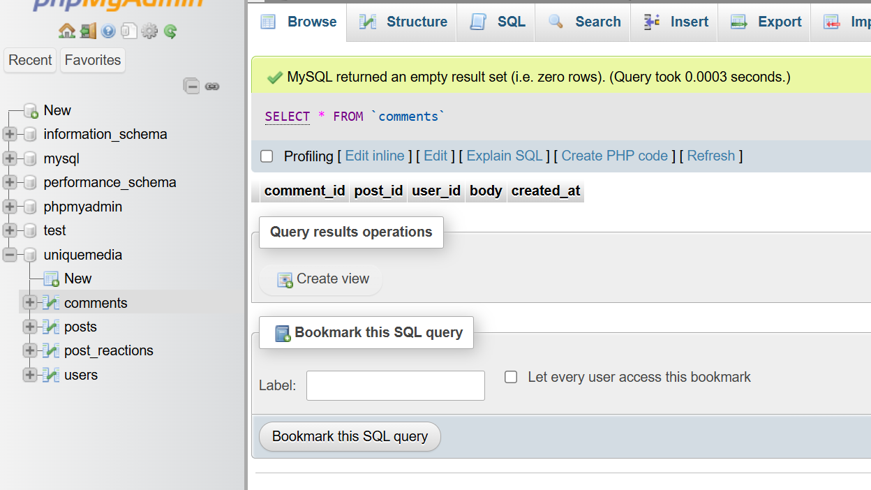

**Post_rections:**

CREATE TABLE post_reactions (

user_id INT NOT NULL,

post_id INT NOT NULL,

reaction ENUM('like','dislike') NOT NULL,

created_at TIMESTAMP DEFAULT CURRENT_TIMESTAMP,

PRIMARY KEY (user_id, post_id),

FOREIGN KEY (user_id) REFERENCES users(user_id),

FOREIGN KEY (post_id) REFERENCES posts(post_id)

);

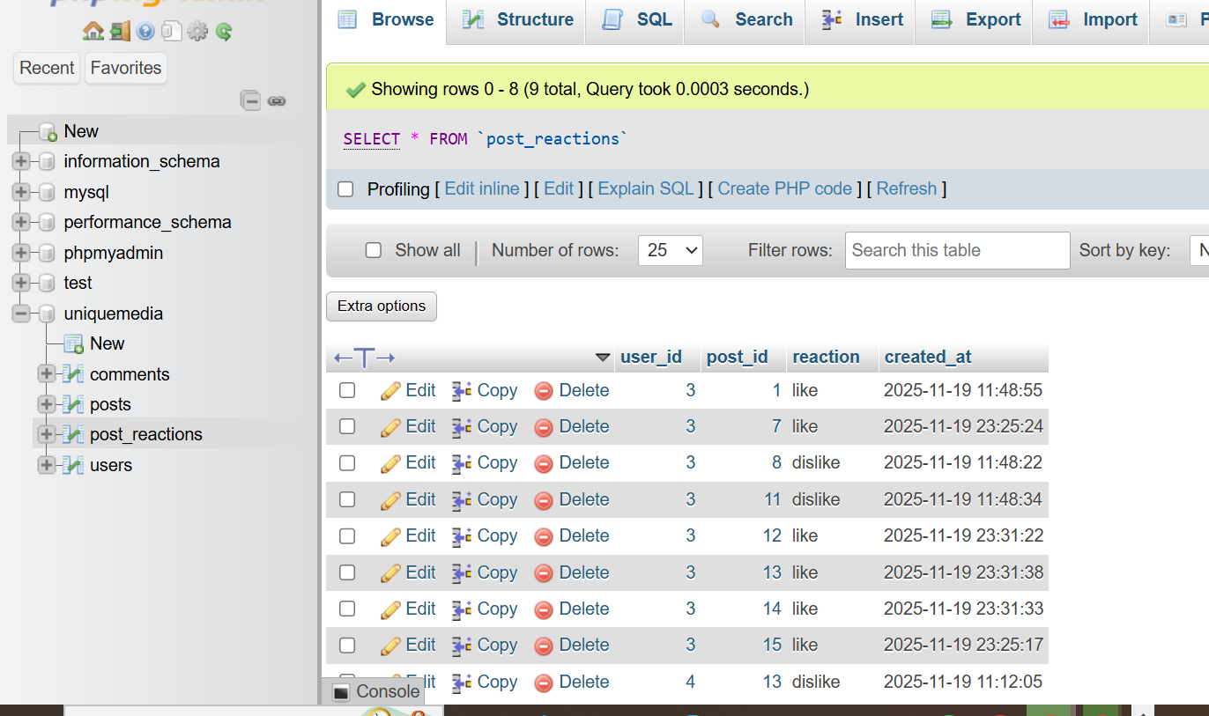

1. **Populate Tables**

After creating the database schema using the SQL DDL statements, each table was populated with sample data to demonstrate how the system operates. The data includes users, posts, comments, and reactions that reflect realistic interactions in the Uniquemedia platform.

The following screenshots show the Browse View of each table in phpMyAdmin after insertion of test records:

• Users table (Browse View)

 • Posts table (Browse View)

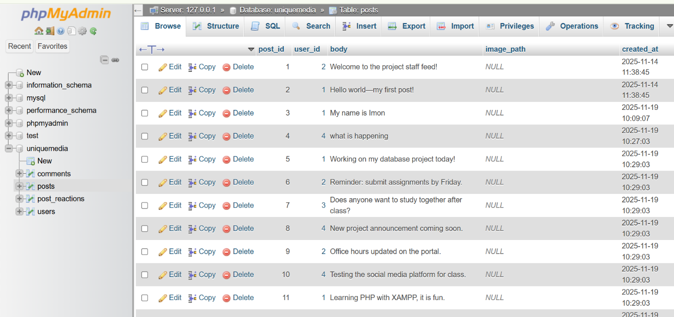 • Comments table (Browse View)

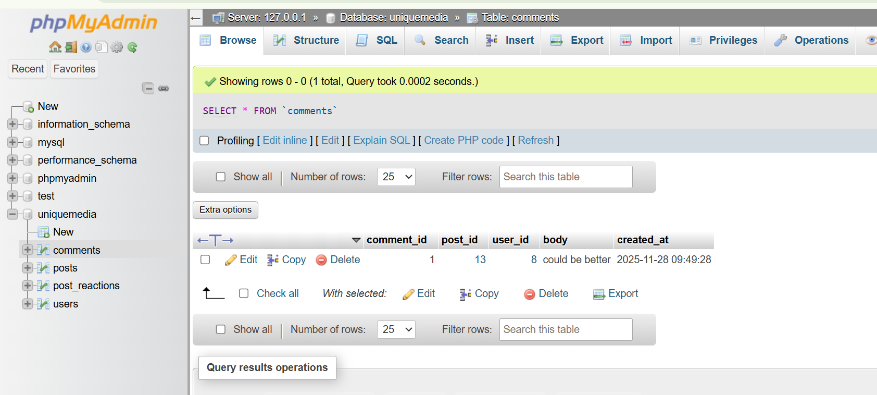 • Post_Reactions table (Browse View)

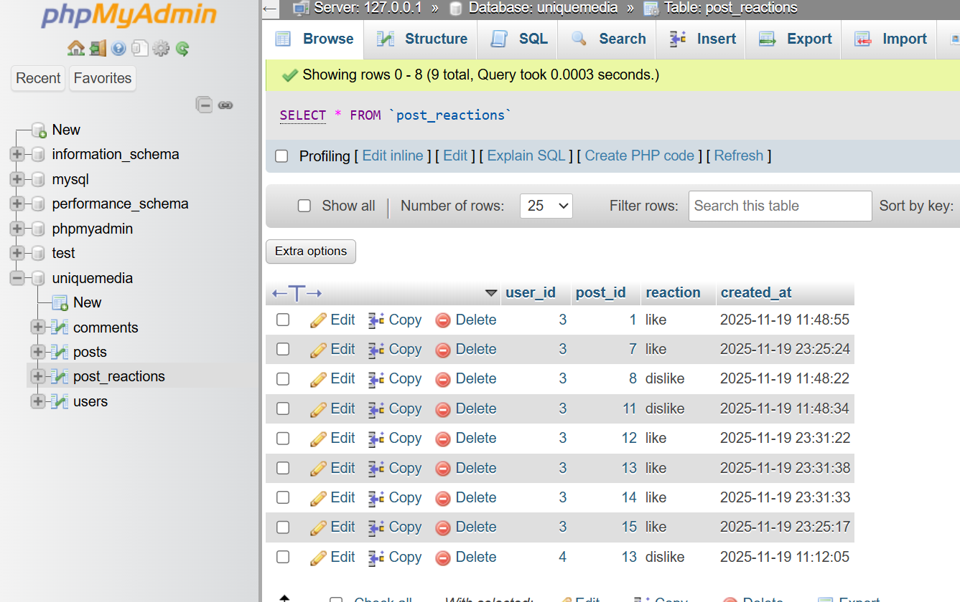

**9. SQL Queries Execute:**

**Join_Query:**

SELECT p.post_id, p.body, u.display_name, u.role

FROM posts p

JOIN users u ON u.user_id = p.user_id;

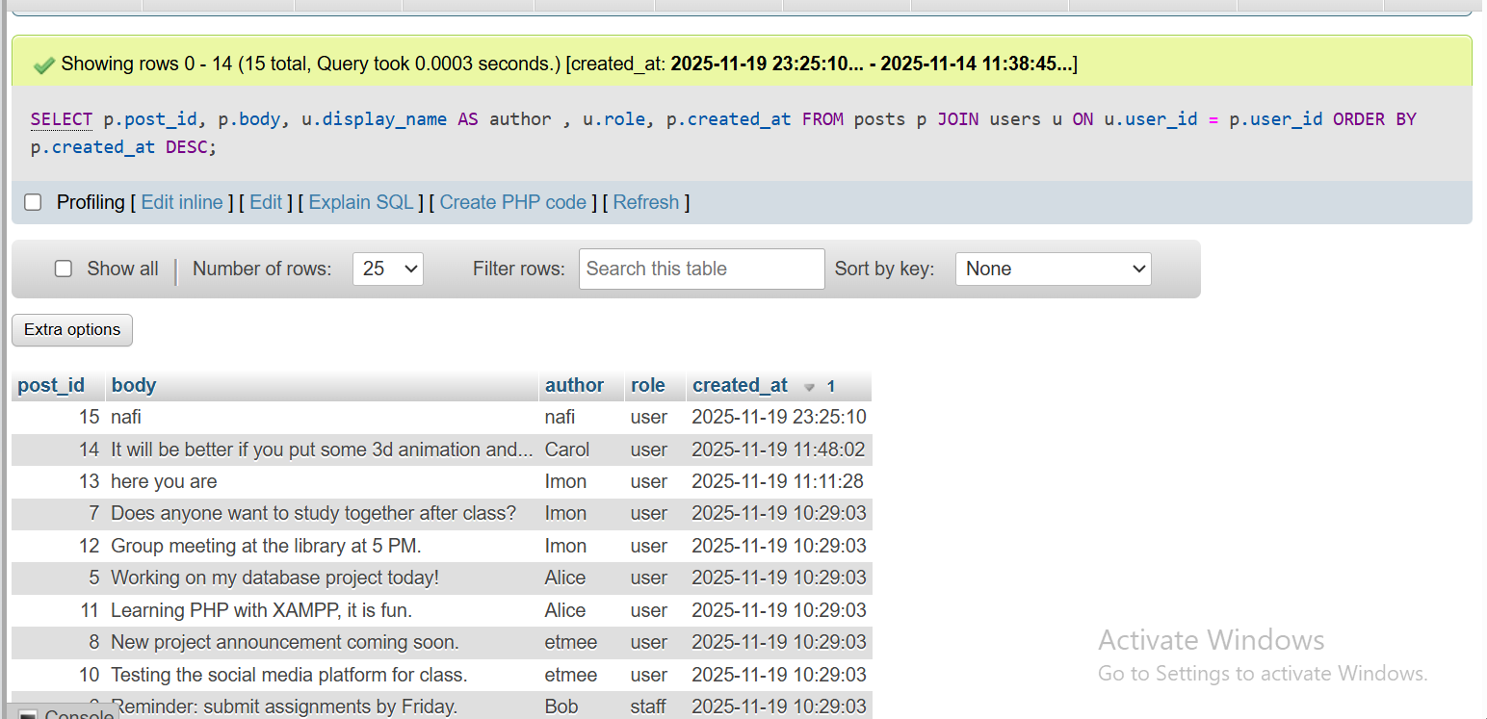

**SELECT with WHERE Clause**

**SELECT \***

**FROM posts**

**WHERE user_id = 1;**

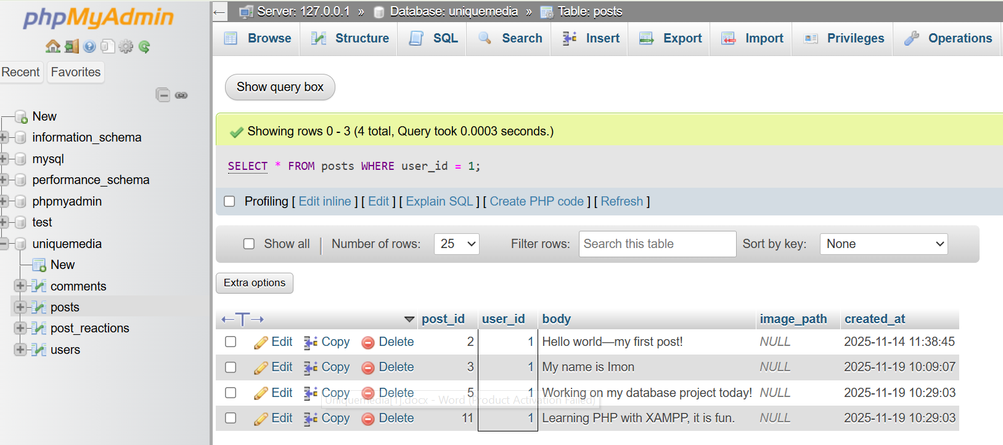

**ORDER BY Clause**

**SELECT post_id, body, created_at**

**FROM posts**

**ORDER BY created_at DESC;**

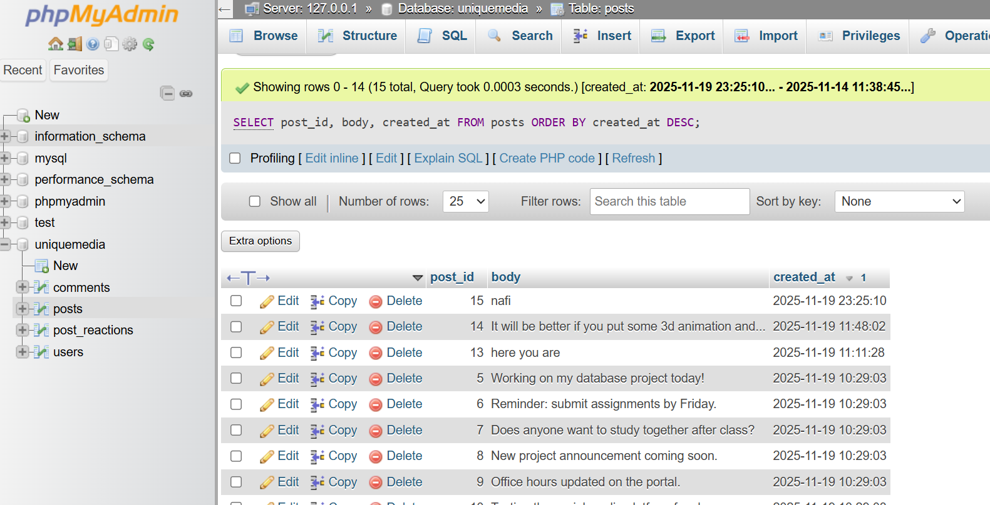

**GROUP BY Clause**

**SELECT user_id, COUNT(*) AS total_posts**

**FROM posts**

**GROUP BY user_id;**

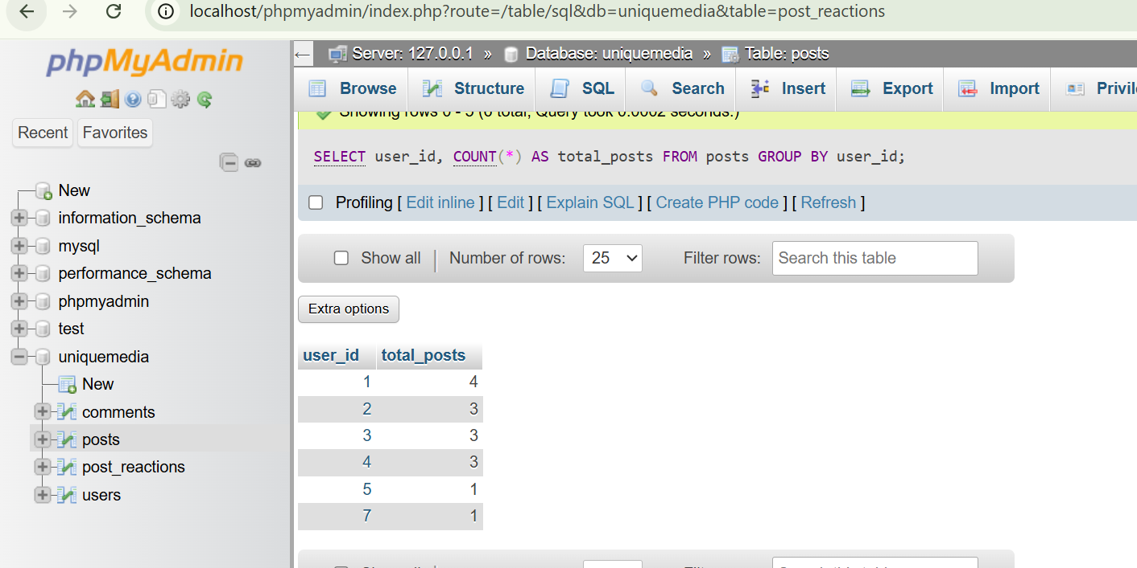

**HAVING Clause**

**SELECT user_id, COUNT(*) AS total_posts**

**FROM posts**

**GROUP BY user_id**

**HAVING total_posts >= 2;**

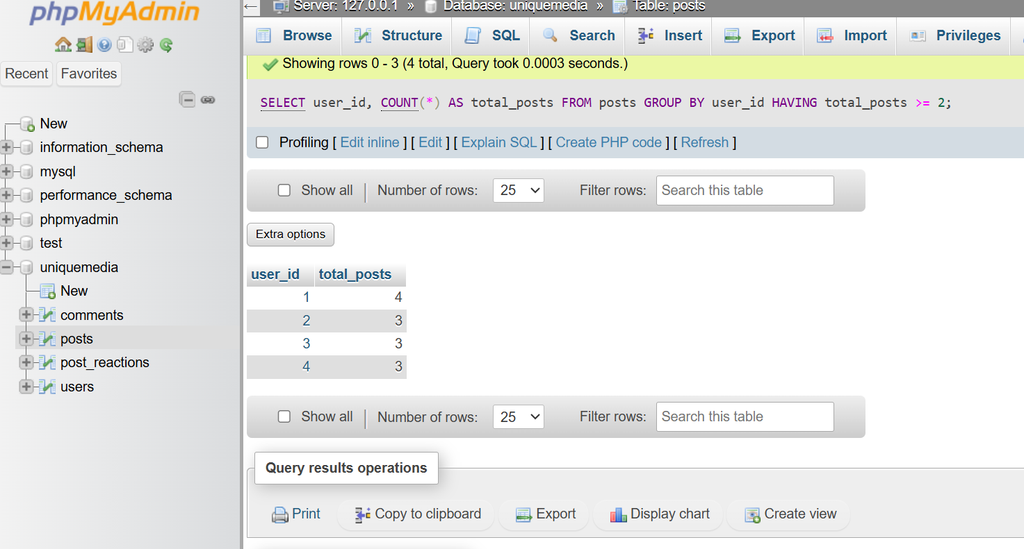

**10Subquiries**

**Nested Subquery (Latest Post Per User)**

**SELECT \***

**FROM posts p**

**WHERE p.created_at = (**

**SELECT MAX(created_at)**

**FROM posts**

**WHERE user_id = p.user_id**

**);**

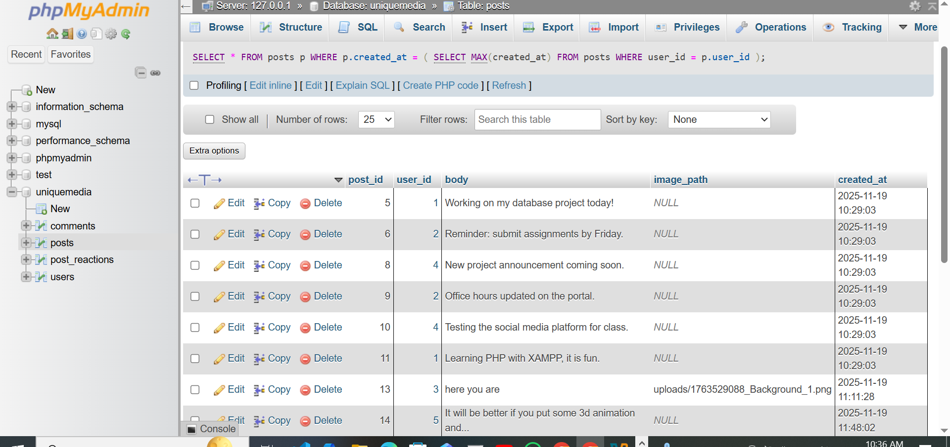

**Aggregate Function (COUNT)**

**SELECT user_id, COUNT(*) AS post_total**

**FROM posts**

**GROUP BY user_id;**

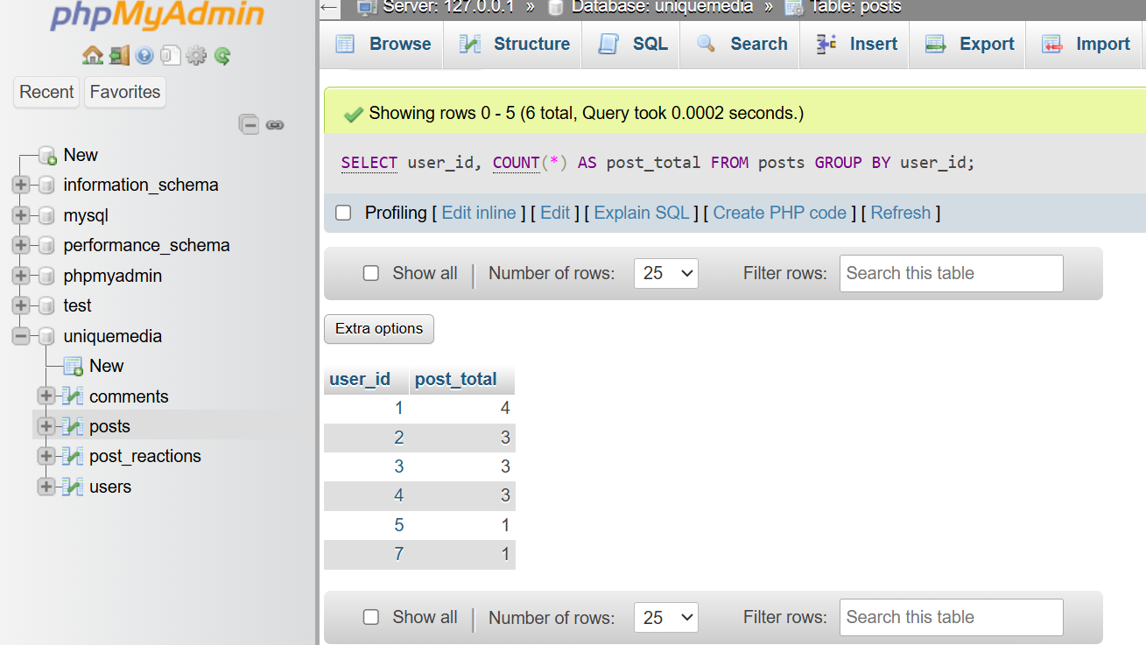

**11FUNCTION**

**Date Function**

**SELECT \***

**FROM posts**

**WHERE DATE(created_at) = CURDATE();**

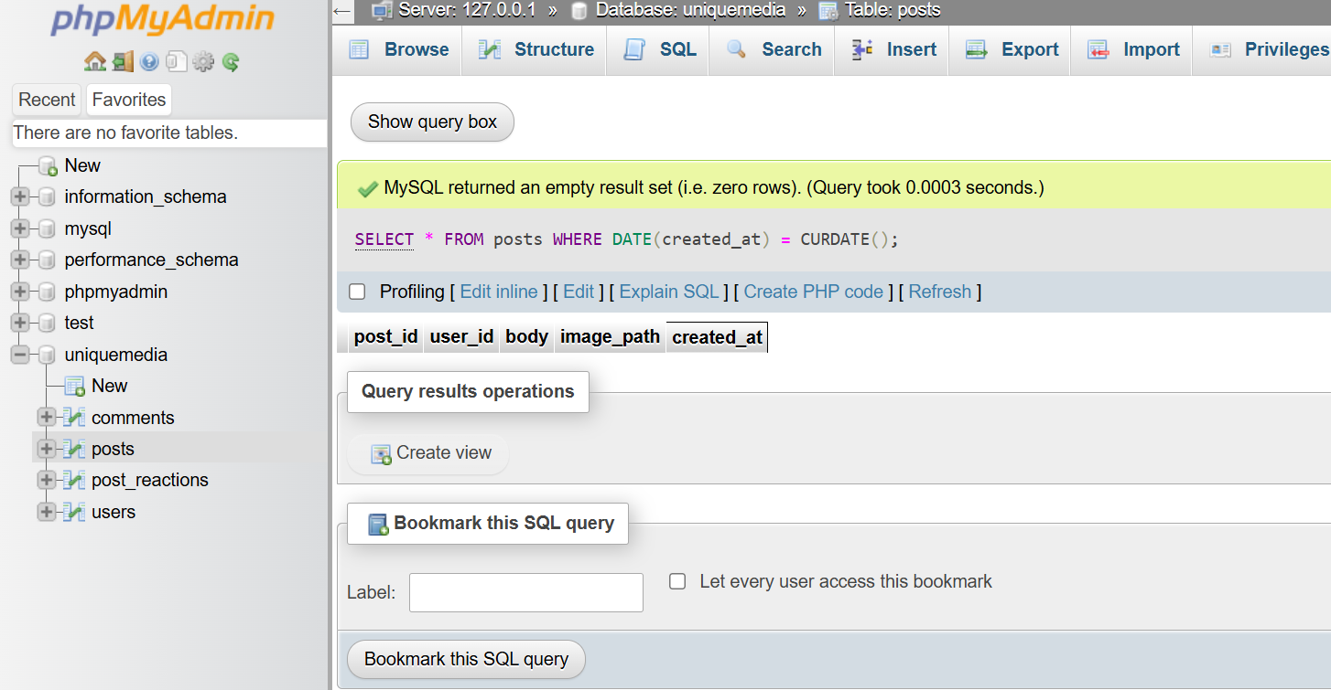

**String Function**

**SELECT UPPER(display_name) AS uppercase_name**

**FROM users;**

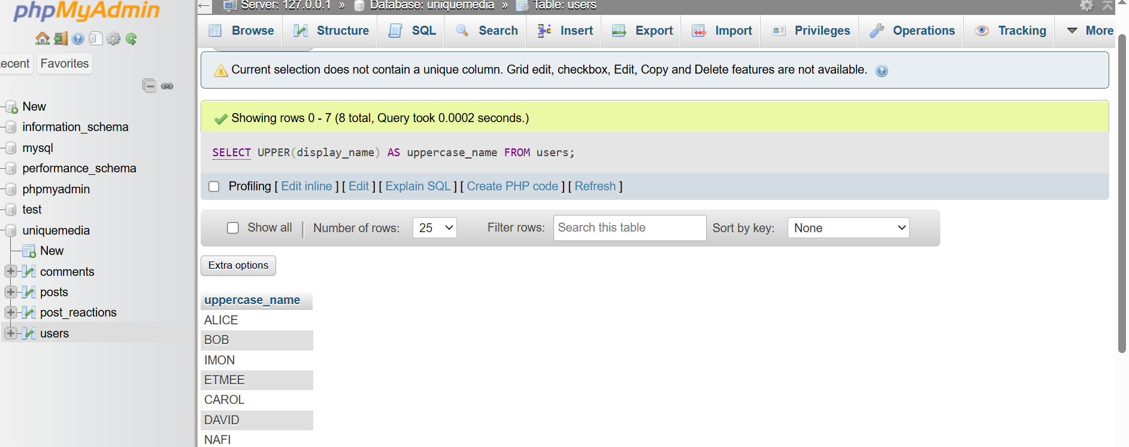

**Math Function**

**SELECT post_id, LENGTH(body) AS text_length**

**FROM posts;**

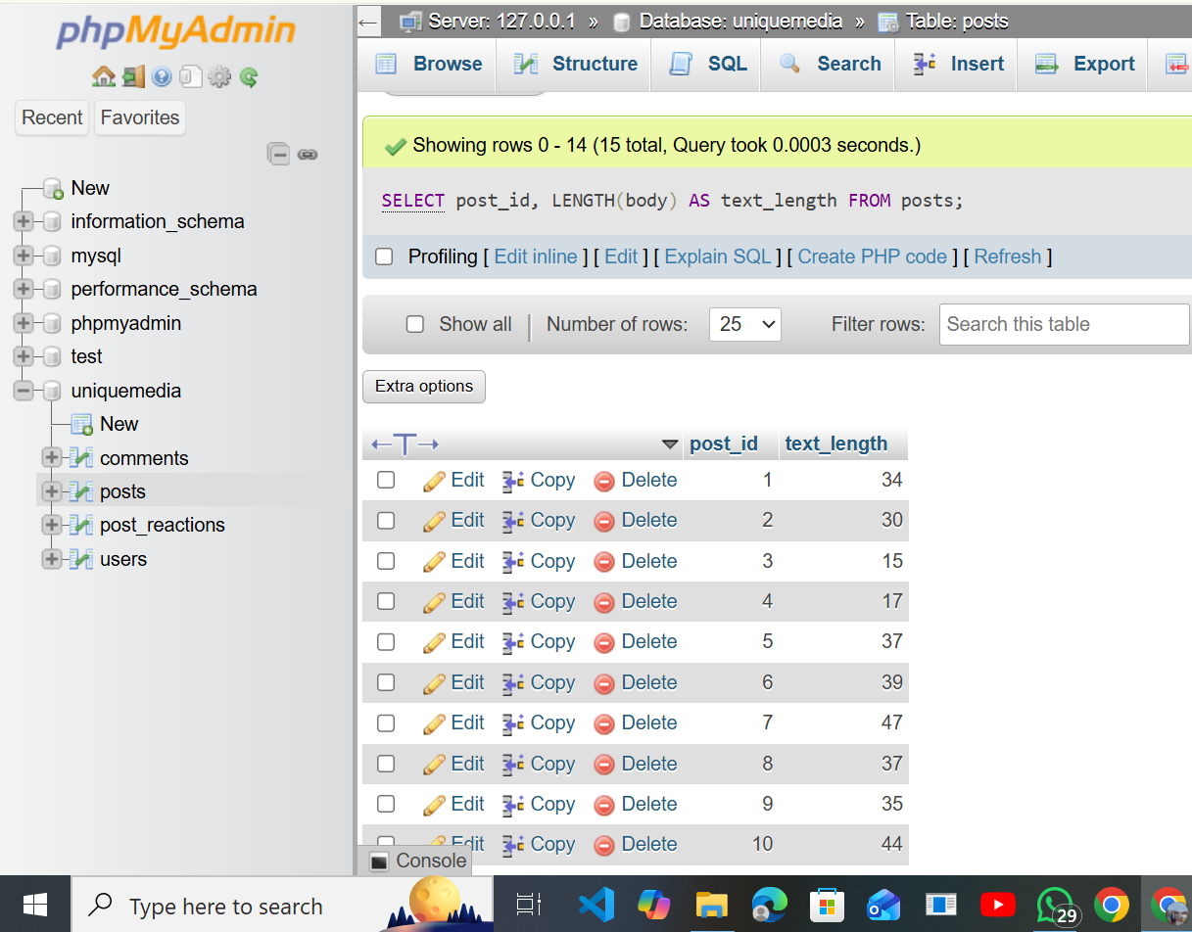

**12 Insert, Update, and Delete Statements**

Place this right after your SQL queries section.

Insert, Update, and Delete Operations

The following statements demonstrate basic data manipulation in the Uniquemedia database.

**INSERT**

**INSERT INTO comments (post_id, user_id, body)**

**VALUES (1, 2, 'Nice progress on the project!');**

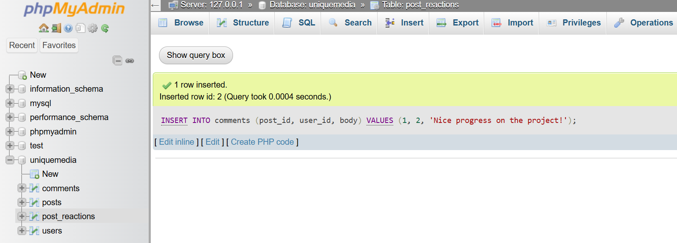

**UPDATE**

**UPDATE users**

**SET role = 'staff'**

**WHERE user_id = 3;**

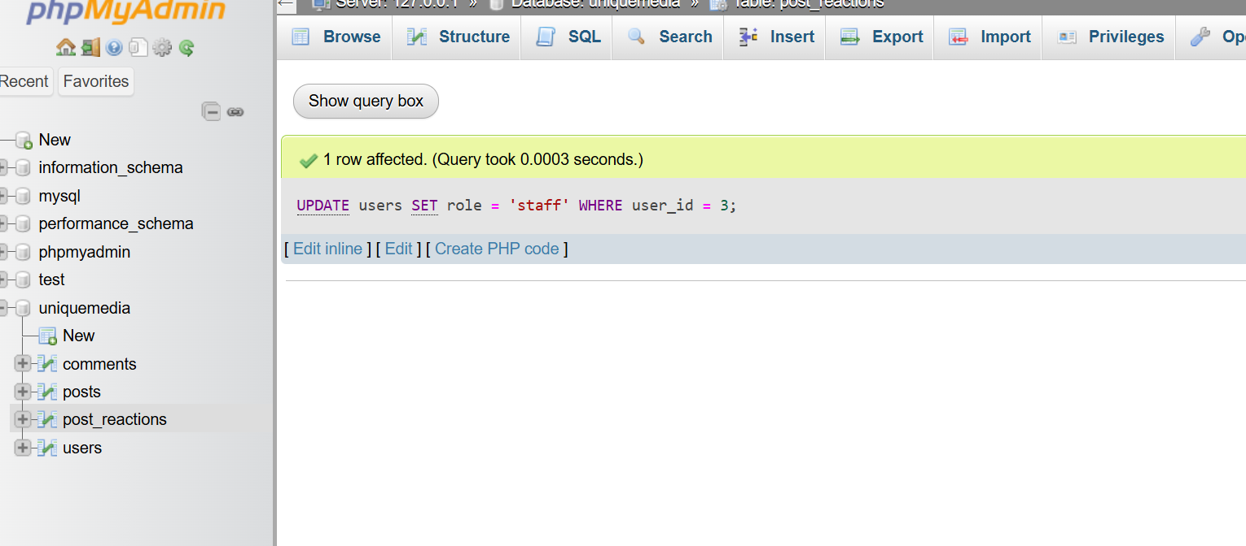

**13ALTER TABLE**

**ALTER TABLE posts**

**ADD COLUMN image_path VARCHAR(255);**

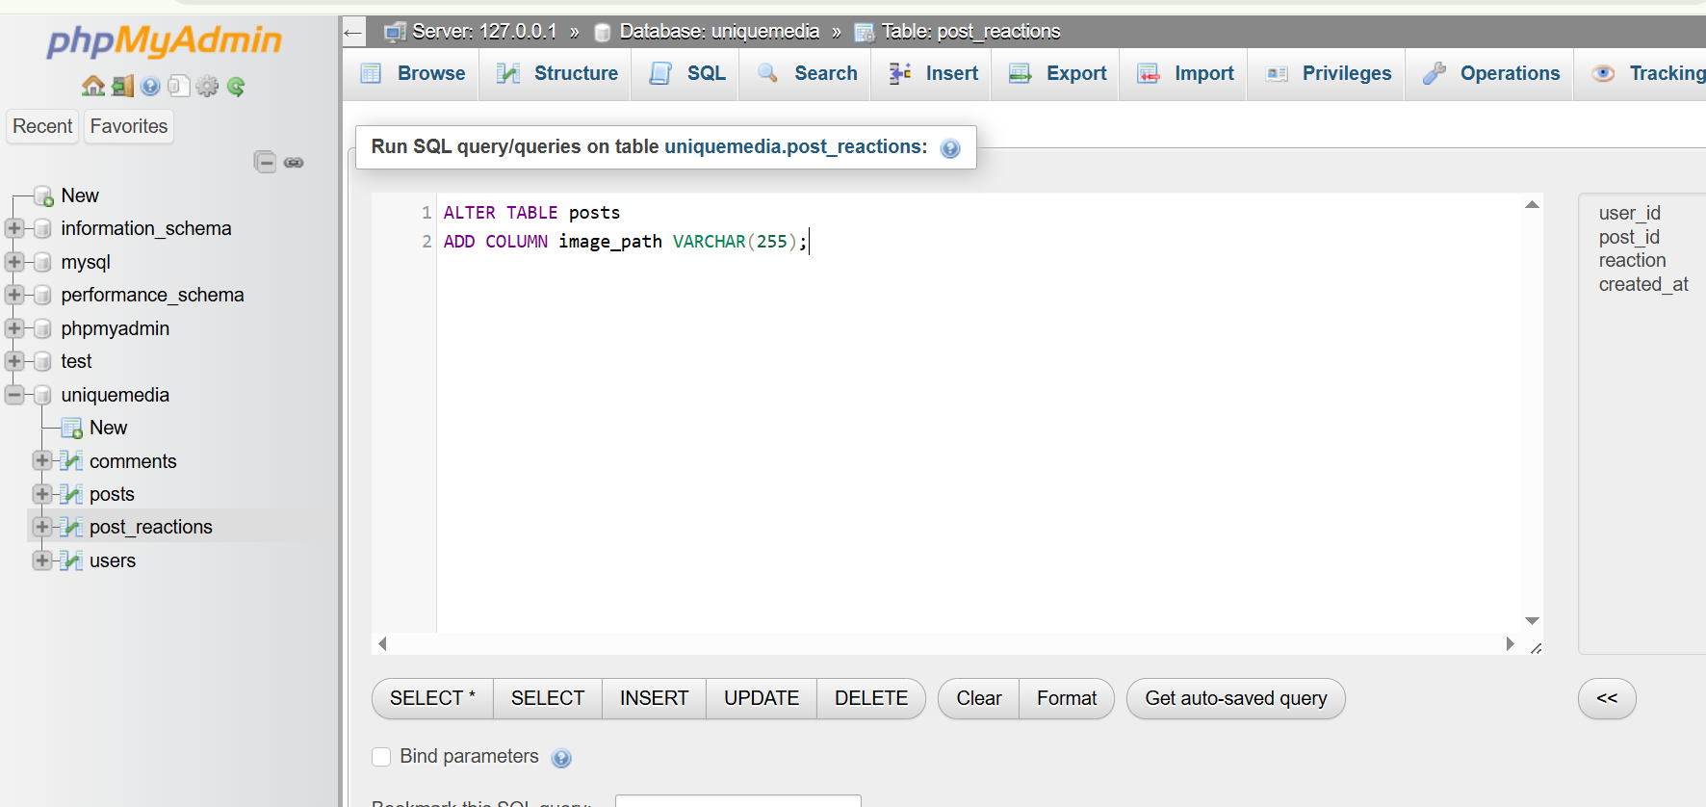

1. **View Definition**

**CREATE VIEW staff_posts AS**

**SELECT p.post_id,**

**p.body,**

**p.image_path,**

**p.created_at,**

**u.display_name AS staff_name**

**FROM posts p**

**JOIN users u ON p.user_id = u.user_id**

**WHERE u.role = 'staff';**

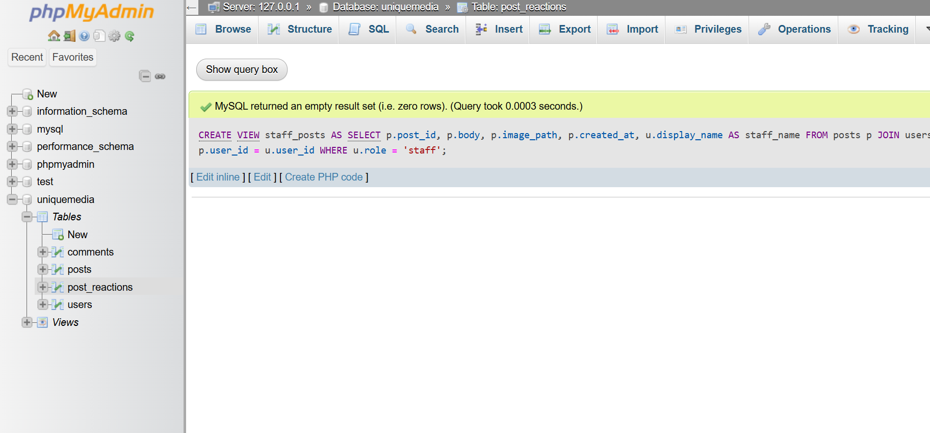

**Indexes**

**CREATE INDEX idx_post_date**

**ON posts(created_at);**

**CREATE INDEX idx_user_role**

**ON users(role);**

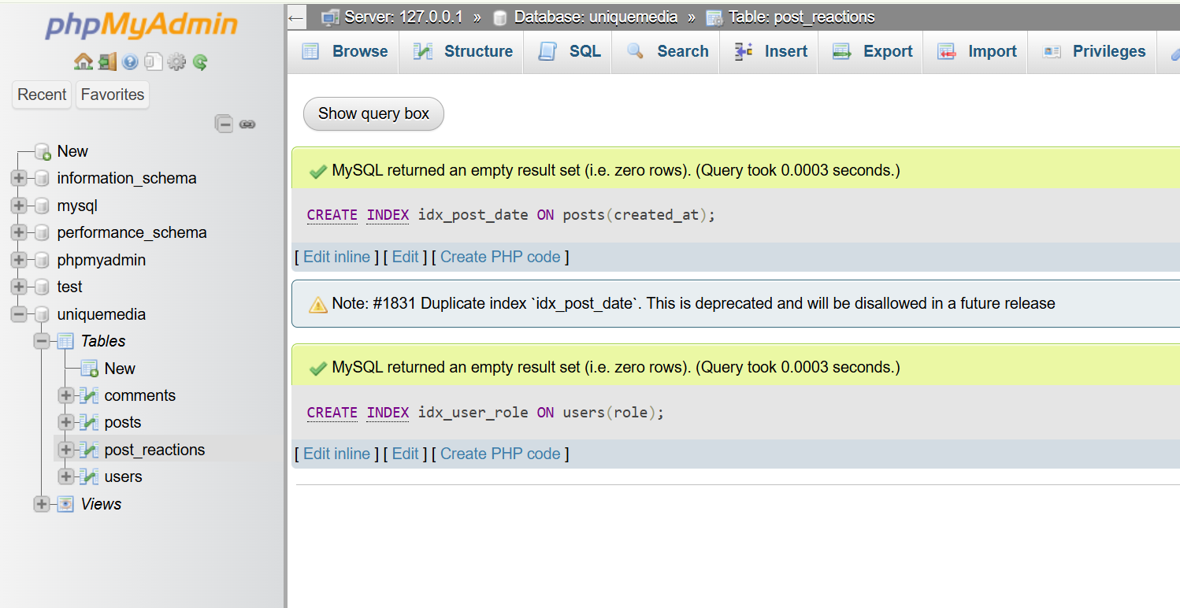

**15. System Features**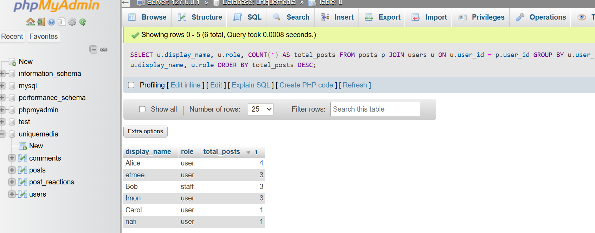

**✔ User Authentication**

• Login / Signup

• Password hashing (SHA-256)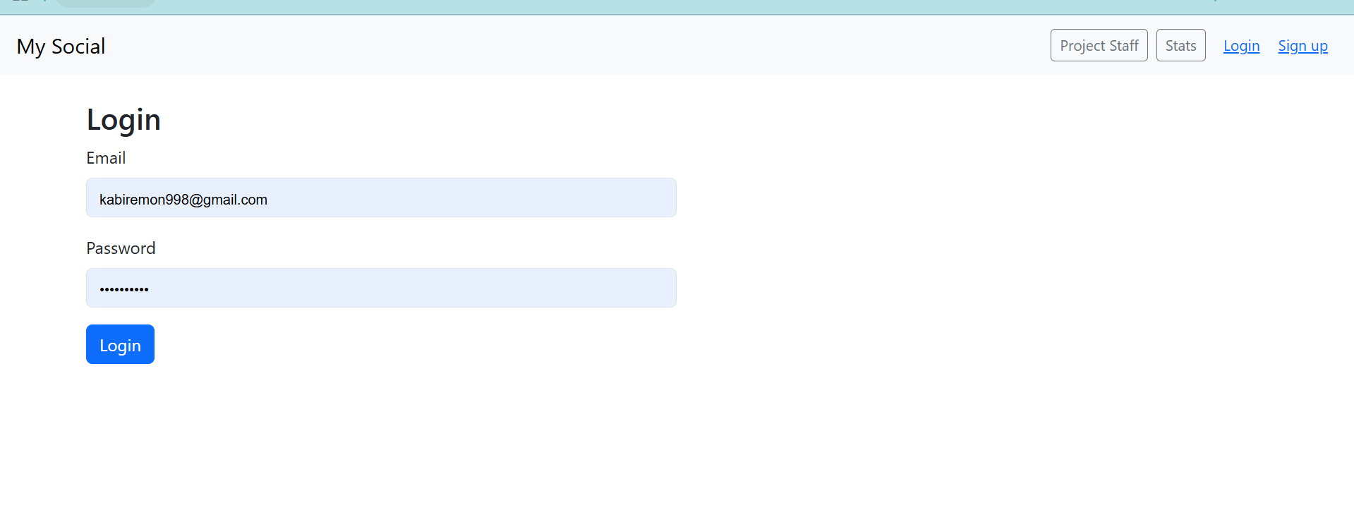

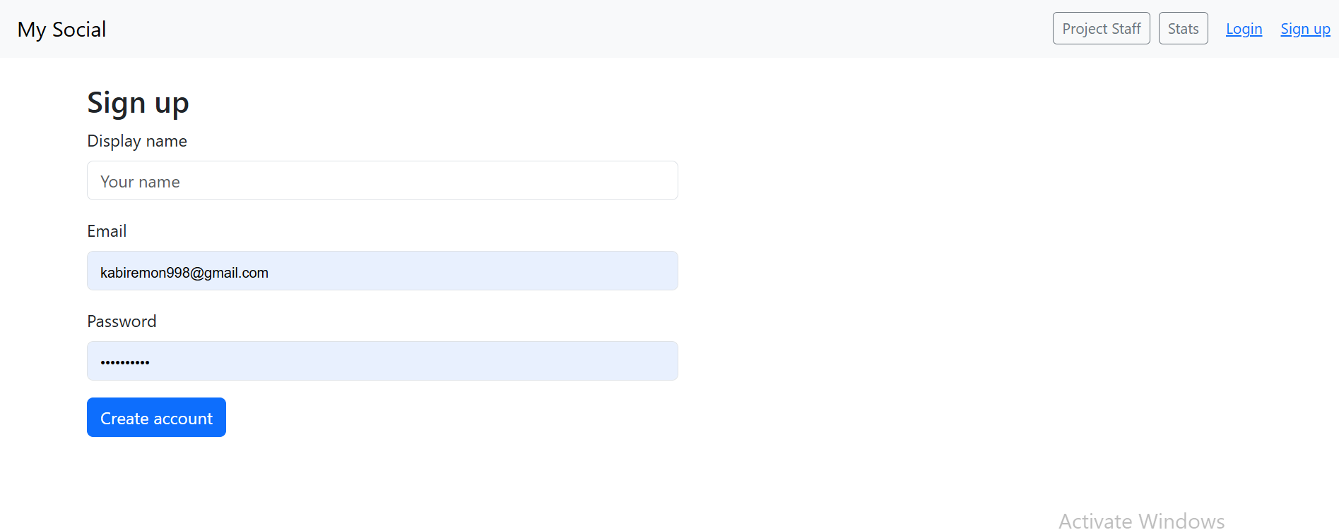

✔ Post Creation

• Text posts

• Image uploads

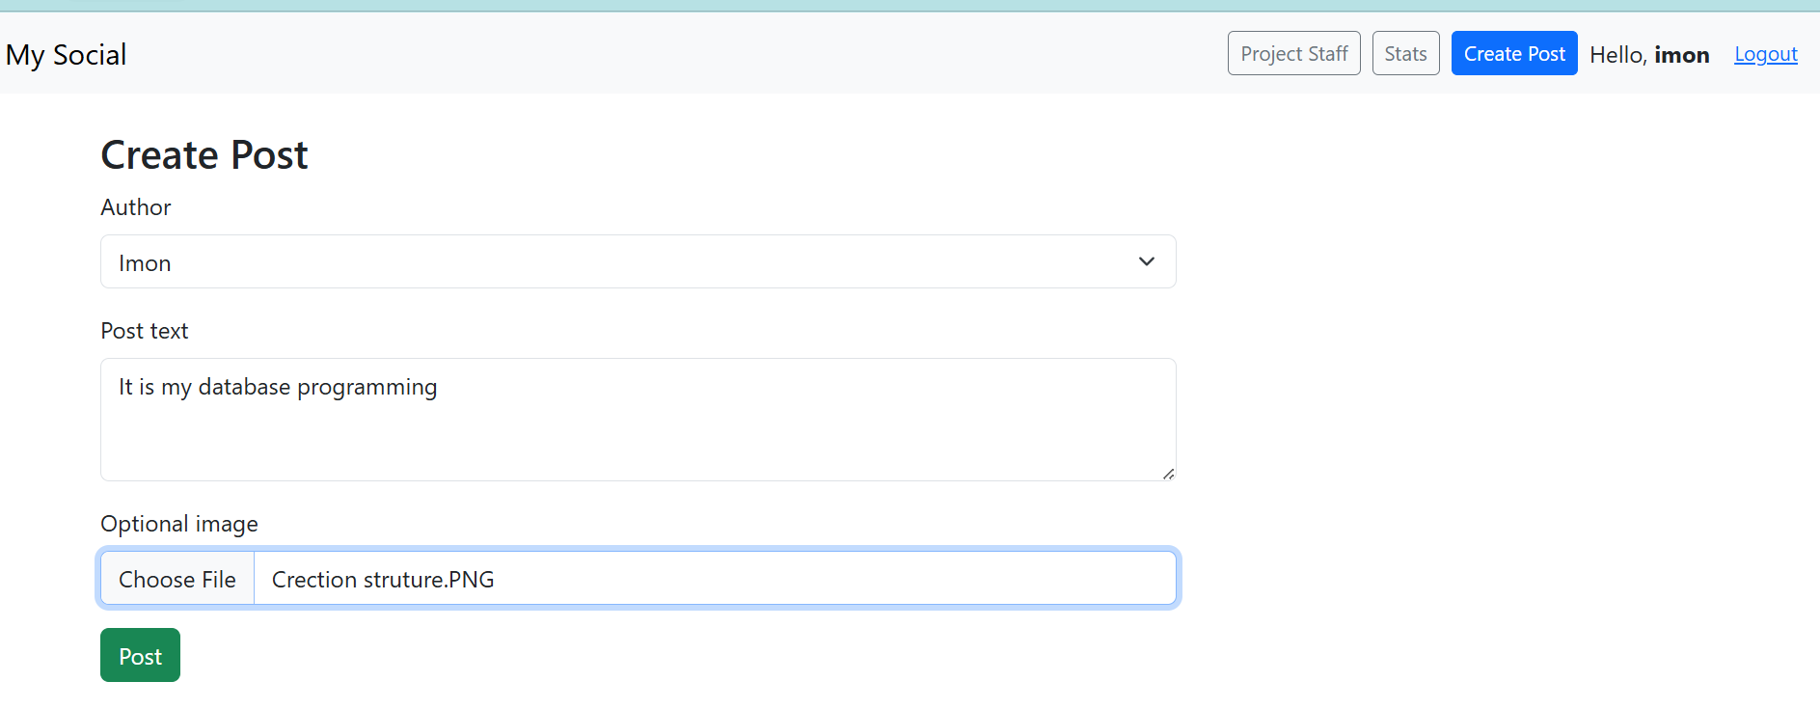

✔ Staff Feed

• Staff-only announcements

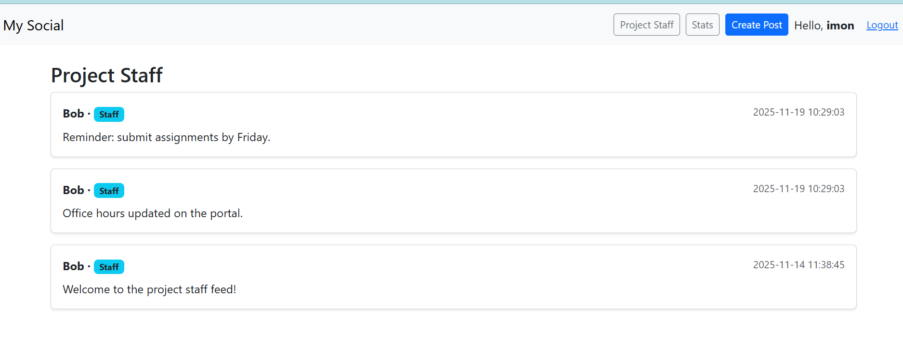

✔ Reactions

• Like / Dislike stored in post_reactions

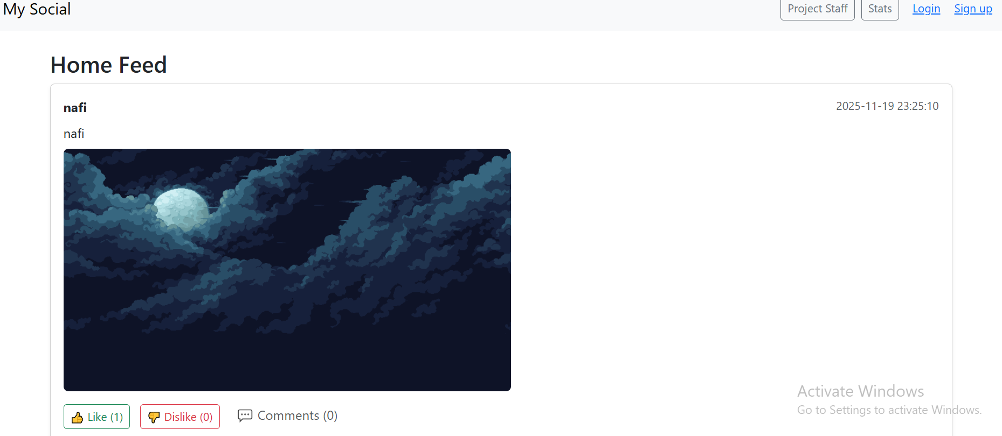

✔ Comments

• Stored in comments table

• Displayed under each post

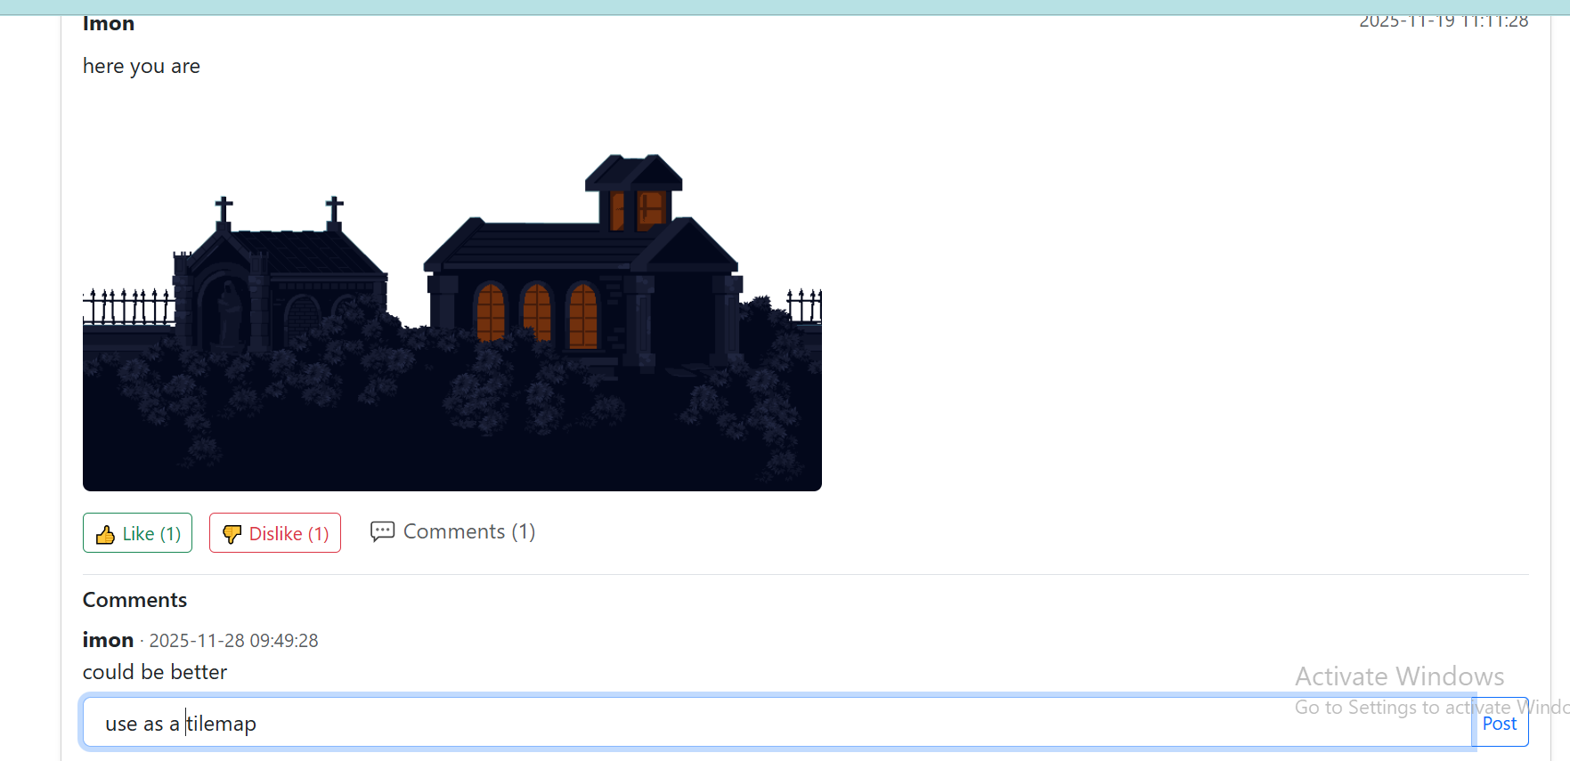

**16Above and Beyond Course Material**

This project goes beyond the basic requirements of the course by implementing several advanced features:

1. Image Upload System

Users can upload images with posts. This required working with PHP file handling, validating file types, and storing file paths in the database—beyond standard SQL operations.

2. Reaction System with Composite Primary Key

The like/dislike feature uses a composite primary key (user_id, post_id) to ensure each user can react only once per post. This demonstrates advanced use of constraints.

3. SQL View for Staff Feed

A database view (staff_posts) was created to simplify queries and support role-based content filtering, showing deeper understanding of SQL abstraction.

4. Index Optimization

Custom indexes were added to improve query performance, demonstrating awareness of database efficiency.

5. Fully Functional Web Integration

The project includes a working front-end with PHP–MySQL integration, user authentication, comments, and real-time reactions, going beyond pure database design

**17. Conclusion**

This project demonstrates a complete end-to-end database-driven application.

Uniquemedia successfully fulfills all course requirements for Database Programming by applying:

• ER Modeling

• Normalization

• SQL DDL & DML

• Aggregation and JOIN queries

• Subqueries

• PHP + MySQL integration

• Real-world features (comments, reactions, image upload)

It provides a practical and engaging way for team members and staff to communicate during a project, showing how database systems support real-world applications.